Ong Jia Aun WEA150022

Tutorial

• What is the current location in your map?

Sydney

• How to define current location in the map?

LatLng sydney = new LatLng(-34, 151);  
mMap.addMarker(new MarkerOptions().position(sydney).title("Marker in Sydney"));  
mMap.moveCamera(CameraUpdateFactory.*newLatLng*(sydney));

• Try setting the current location to Kuala Lumpur, Malaysia.

• Try changing the name of the marker of the map to Kuala Lumpur.

LatLng kualaLumpur = new LatLng(3.1412, 101.68653);  
mMap.addMarker(new MarkerOptions().position(kualaLumpur).title("Marker in Kuala Lumpur"));  
mMap.moveCamera(CameraUpdateFactory.*newLatLng*(kualaLumpur));

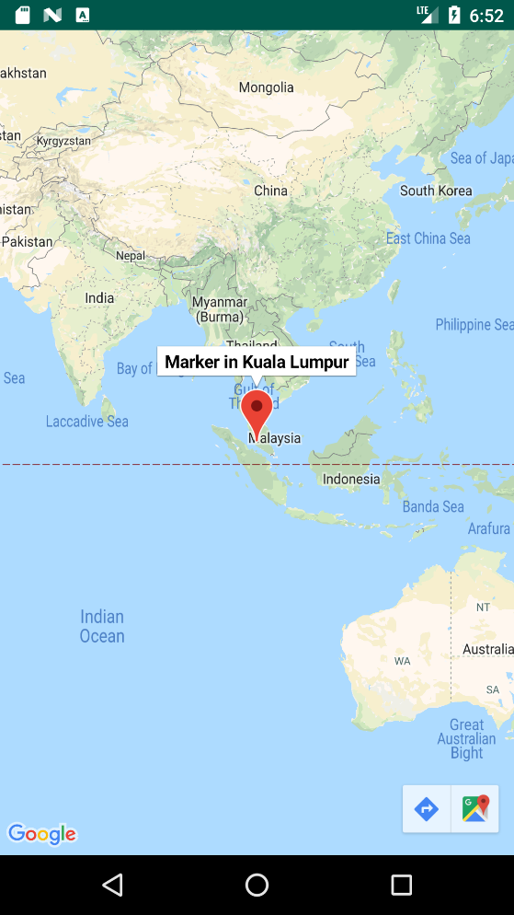

• What are the dependencies needed to access to maps and location information? What are the purposes of each of these dependencies?

implementation 'com.google.android.gms:play-services-maps:16.0.0'

Allow use of Google Maps SDK API